Backend Development With Node.js
Project documentation

1. Introduction :
• Project Title: AI BlogNest API – An AI-Augmented Blog Application
• Team ID: SWTID-2026-8907
• Team leader: Saadiya Sabreen N
• Id: 24bsccs49@cttewc.edu.in
• Team Members:
• Deepalakshmi S
• Id: 24bsccs13@cttewc.edu.in
• Sakthi Sri K
• Id: 24bsccs33@cttewc.edu.in
• Mahalakshmi R
• Id: 24bsccs53@cttewc.edu.in
2. Project Overview
AI BlogNest is a backend REST API developed using Node.js, Express.js, MongoDB, Mongoose, and Google Gemini AI.
The system allows users to create and manage blog posts through secure API endpoints. The application provides functionality to create, view, update, and delete blogs.
The project uses JWT authentication to provide secure access to protected routes. Users can register and log in using their email and password. Passwords are protected using bcrypt, and JWT tokens are used to authenticate authorized users.
The backend follows a structured architecture with separate controllers, models, routes, middleware, services, and configuration folders. This makes the project organized, maintainable, and easier to extend.
The main feature of AI BlogNest is the integration of Google Gemini AI, which provides AI-powered features such as automatic blog generation and blog summarization.
3. Objectives of the Project
• To develop a backend REST API for managing blog posts.
• To implement secure user registration and login.
• To use JWT authentication for protecting API routes.
• To perform CRUD operations on blog posts.
• To validate required blog fields such as title, content, and category.
• To integrate Google Gemini AI into the backend application.
• To generate blog content automatically using AI.
• To summarize existing blog content using AI.
• To understand REST API development using Node.js and Express.js.
4. Technologies Used
Node.js – Used as the runtime environment for executing JavaScript on the server side.
Express.js – Web framework used to build RESTful APIs and handle HTTP requests.
MongoDB – NoSQL database used to store user and blog data.
Mongoose – Used to connect the Node.js application with MongoDB and define database models.
JWT (JSON Web Token) – Used for authentication and secure access to protected APIs.
bcrypt – Used to securely hash and protect user passwords.
Google Gemini AI – Used to provide AI-powered blog generation and summarization features.
Thunder Client – Used to test API endpoints and check the responses from the backend
5. System Architecture
The AI BlogNest backend follows a structured backend architecture.
Model:
Defines the database schemas for users and blogs.
View:
Not used because this project provides backend APIs and does not contain a frontend interface.
Controller:
Handles the main application logic and processes user requests.
Routes:
Defines the API endpoints and connects them to the appropriate controllers.
Middleware:
Handles authentication and checks whether the user has permission to access protected routes.
Services:
Contains the Gemini AI service used to communicate with Google Gemini AI.
Flow:
User → API Request → Route → Middleware → Controller → Service/Database → Response
For AI requests:
User → API Request → Route → Controller → Gemini Service → Google Gemini AI → Response
6. Folder Structure
AI-BLOGNEST/
│
├── config/
│
├── controllers/
│ ├── authController.js
│ ├── blogController.js
│ └── aiController.js
│
├── middlewares/
│ ├── authMiddleware.js
│ └── errorMiddleware.js
│
├── models/
│ ├── user.model.js
│ └── blog.model.js
│
├── routes/
│ ├── user.route.js
│ ├── blog.route.js
│ └── ai.route.js
│
├── services/
│ └── gemini.service.js
│
├── node_modules/
│
├── .env
├── .gitignore
├── index.js
├── package.json
├── package-lock.json
└── README.md
7. Features
• User Registration
• Secure User Login
• Password Hashing using bcrypt
• JWT Authentication
• Protected API Routes
• Create New Blog
• View All Blogs
• View Blog by ID
• Update Blog
• Delete Blog
• Blog Validation
• AI Blog Generation
• AI Blog Summarization
• Error Handling
• MongoDB Database Integration
8. Project Setup
Install Node.js
Download and install Node.js before running the project.
Create Project
npm init -y
Install Dependencies
The project uses dependencies such as:
npm install express mongoose jsonwebtoken bcrypt dotenv
The Google Gemini AI package is also used for AI functionality.
Start Server
node index.js
For development, the server can also be started using:
npm run dev
The MongoDB connection and other sensitive configuration values are stored in the .env file.
9. API Development
The AI BlogNest backend provides REST APIs for authentication, blog management, and AI-powered features.
Authentication APIs
User Registration
Allows new users to create an account by providing the required user details.
User Login
Allows registered users to log in using their email and password. After successful login, the system generates a JWT token.
JWT Token Authentication
The generated JWT token is used to access protected API routes. The authentication middleware verifies the token before allowing access.
Blog APIs
Create Blog
Creates a new blog post in the database.
Get All Blogs
Retrieves all available blog posts from the database.
Get Blog by ID
Retrieves a particular blog using its unique blog ID.
Update Blog
Updates the details of an existing blog.
Delete Blog
Deletes a selected blog from the database.
All required fields such as title, content, and category are validated before processing the request.
AI APIs
Generate Blog
The Generate Blog API accepts a topic and category from the user.
The request is sent to the Gemini AI service, which generates blog content automatically based on the provided topic and category.
Example Topic:
Artificial Intelligence
Summarize Blog
The Summarize Blog API accepts existing blog content as input.
The content is sent to Gemini AI, which generates a shorter and meaningful summary of the blog.
10. Middleware
Middleware is used to process requests before they reach the controller.
Authentication Middleware
The authentication middleware verifies the JWT token provided by the user.
If the token is valid, the user is allowed to access the protected route.
If the token is missing or invalid, access to the protected API is denied.
Error Middleware
The error middleware handles application errors and returns appropriate HTTP status codes and error messages.
Examples of HTTP status codes used include:
200 – Success
201 – Created
400 – Bad Request
401 – Unauthorized
404 – Not Found
11. Database Development
MongoDB is used as the database for storing user and blog information.
Mongoose is used to connect the Node.js application with MongoDB and manage database schemas.
The project contains models for:
• Users Collection
• Blogs Collection
The user model stores user information such as email and password.
The blog model stores information related to blog posts, including fields such as:
• Title
• Content
• Category
• User information
The database connection details are stored securely in the .env file.
12. Project Execution
The following steps are followed to execute the AI BlogNest project:
• Start the MongoDB database.
• Start the Node.js server.
• Open Thunder Client in VS Code.
• Register a new user using the Register API.
• Login using the registered user's email and password.
• Receive the JWT authentication token.
• Use the token to access protected Blog APIs.
• Create a new blog.
• View all blogs.
• View a particular blog using its ID.
• Update an existing blog.
• Delete a blog.
• Use the Generate Blog API with a topic and category.
• Use the Summarize Blog API with existing blog content.
• Check the API responses returned by the server.
13. Output Screenshots
Register Output
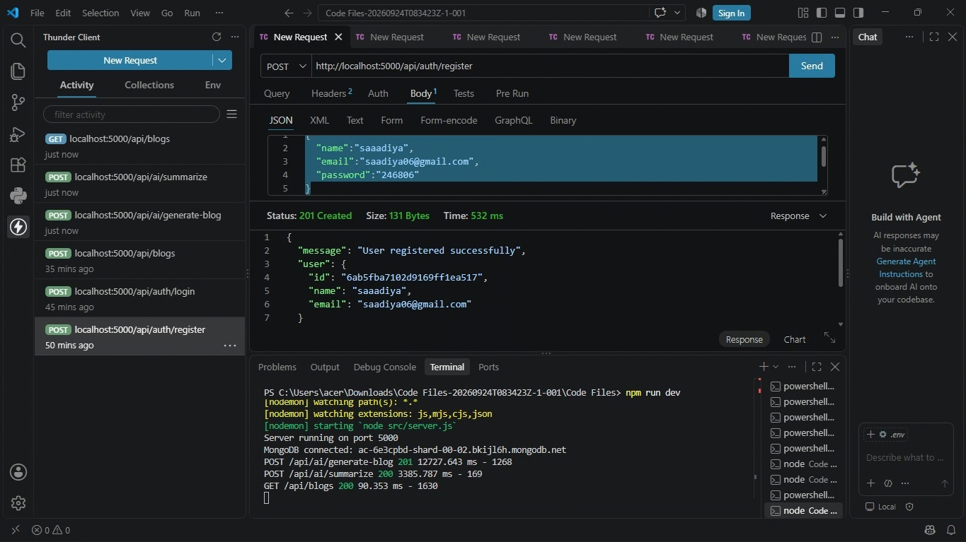

Login Output
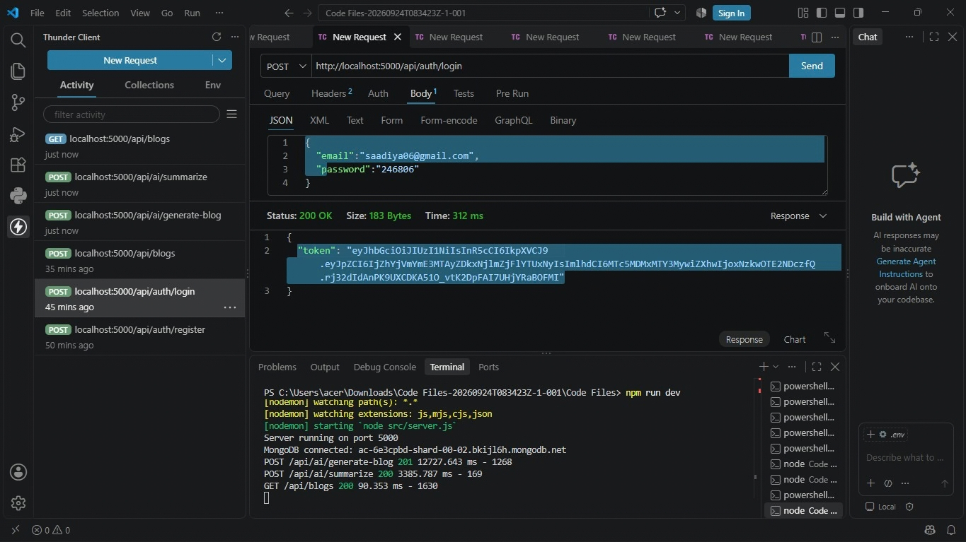

Create Blog Output
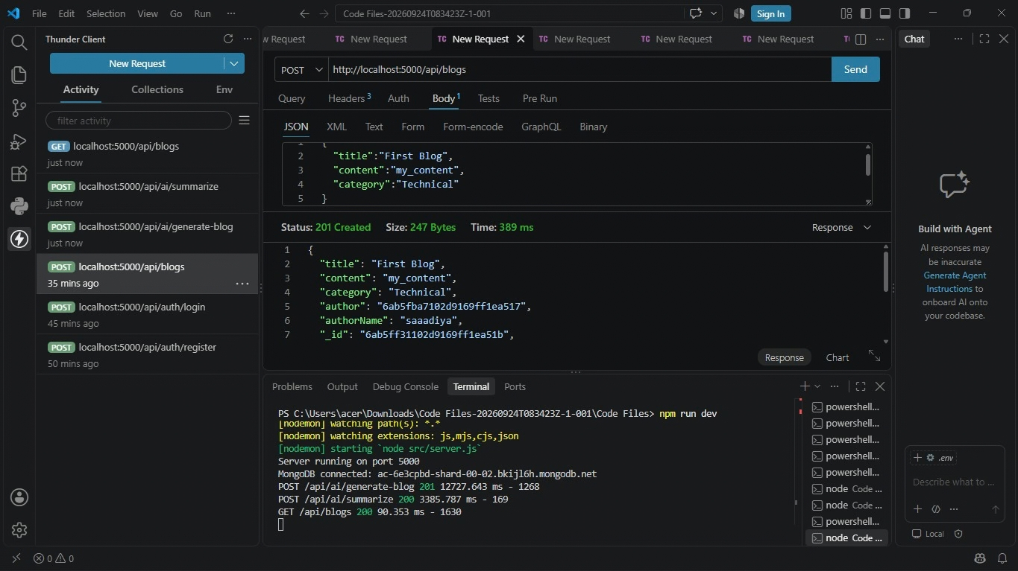

Generate Blog Output
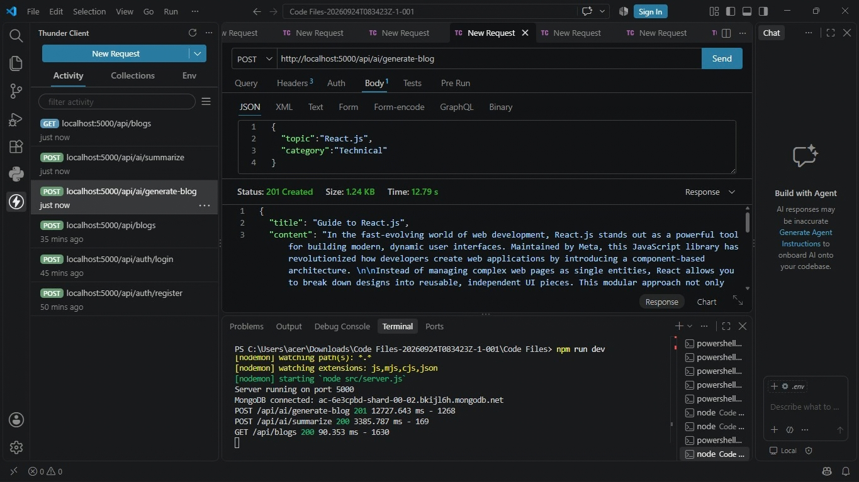

Summarize Blog Output
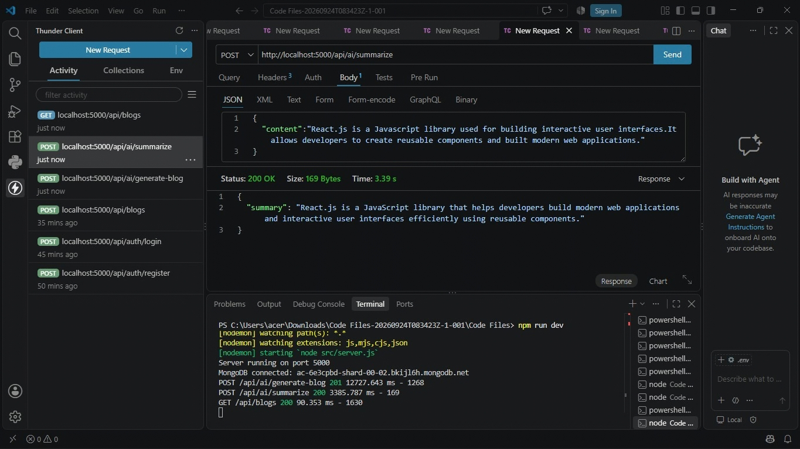

Get Blog by Content Output
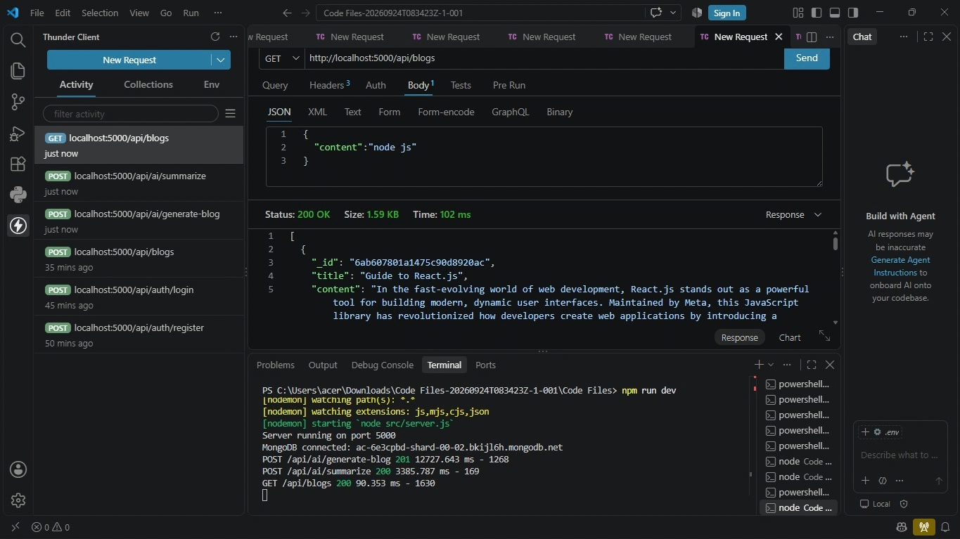

14. Demo Video
Demo Video Link:
InShot_20260925_141331292.mp4
The demo video shows the complete working of the AI BlogNest API, including:
• User registration
• User login
• JWT token generation
• Blog creation
• Viewing blogs
• Updating blogs
• Deleting blogs
• AI-powered blog generation
• AI-powered blog summarization
• API testing using Thunder Client
• Error handling

15. Future Enhancements
• Develop a frontend interface for users to easily interact with the blog application.

• Implement role-based access control for different types of users.
• Add advanced search and filtering options for blogs.
• Add support for blog tags and categories.
• Implement pagination for large numbers of blog posts.
• Add AI-powered blog title and keyword suggestions.
• Add AI-powered content improvement and grammar correction.
• Add user profile management.
• Deploy the application on cloud platforms such as AWS or Render.
• Improve the AI features with additional Gemini-powered functionalities.

